IDA-1290-5 Bearing Replacement Kit

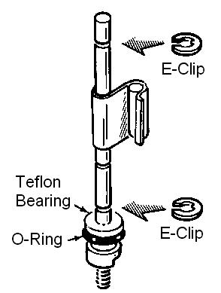
The IDA-1290-5 kit is a collection of all of the parts needed to rebuild the bearings of the ID-1290 and ID-1590 wind direction and speed sensor booms from Heathkit. The kit includes new Teflon bearings, the O-rings used to “self-center” the bearings, and new E-clips to replace all of the old ones.

Begin by carefully removing the wind cups and direction indicator from the boom assembly.

Open up the individual speed and direction housings and remove the steel shafts from each of them.
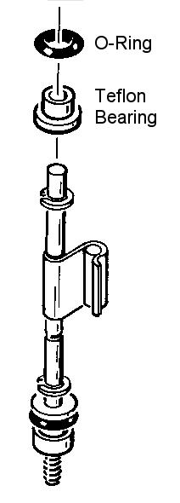
Remove the old Teflon Bearings, O-Rings and E-Clips. Using either steel wool, or very fine sandpaper, clean up the area of the shaft where it was in contact with the bearings. You only want to remove any dirt or corrosion.

Now place one new O-Ring on each of the new Teflon Bearings. Replace the Teflon Bearing assemblies and E-Clips as per the original manual or using the diagrams at the right.

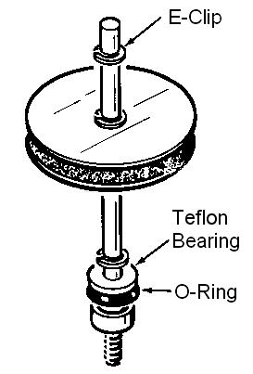
Make certain that you do not mix the old and new parts. The new Teflon bearings have a different outside dimension and that is adjusted for by the O-Rings. These must be used in combination with each other to fit properly. The bottom E-Ring also serves as a thrust surface against the bottom bearing and this E-Clip must be replaced. Keeping the old E-Clip could cause premature wearing of the bottom bearing due to corrosion or dirt on the older E-Clip.

